A furnace is an equipment to melt metals for casting or heat materials for change of shape (rolling, forging etc) or change of properties (heat treatment).

Furnace ဆိုတာကေတာ႔ သတၱဳပစၥည္းေတြကို ပံုသြန္းေလာင္းဖို႔ ဒါမွမဟုတ္ အပူေပးၿပီး အျပားခတ္ျခင္း၊ ပန္းပဲထုျခင္းျပဳလုပ္ႏိုင္ရန္ ႏွင္႔ ဂုဏ္သတၱိေတြ ေျပာင္းလဲသြားေအာင္ heat treatment ျပဳလုပ္ေပးႏိုင္တဲ႔ (မီးဖို) ကိရိယာတစ္ခုပဲ ျဖစ္ပါတယ္။

4.1 Types and Classification of Different Furnaces

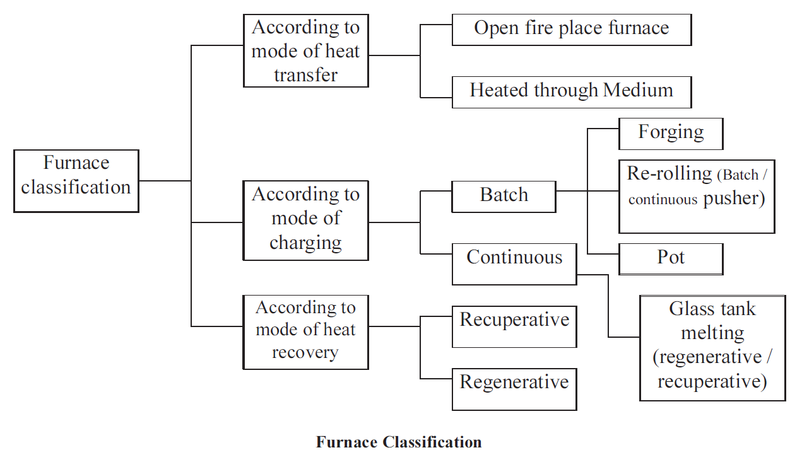

Based on the method of generating heat, furnaces are broadly classified into two types namely combustion type (using fuels) and electric type. In case of combustion type furnace, depending upon the kind of combustion, it can be broadly classified as oil fired, coal fired or gas fired.

• Based on the mode of charging of material furnaces can be classified as (i) Intermittent or Batch type furnace or Periodical furnace and (ii) Continuous furnace.

• Based on mode of waste heat recovery as recuperative and regenerative furnaces.

• Another type of furnace classification is made based on mode of heat transfer, mode of charging and mode of heat recovery as shown in the Figure 4.1 below.

**Characteristics of an Efficient Furnace**

Furnace should be designed so that in a given time, as much of material as possible can be heated to an uniform temperature as possible with the least possible fuel and labour. To achieve this end, the following parameters can be considered.

• Determination of the quantity of heat to be imparted to the material or charge.

• Liberation of sufficient heat within the furnace to heat the stock and overcome all heat

losses.

• Transfer of available part of that heat from the furnace gases to the surface of the heating

stock.

• Equalisation of the temperature within the stock.

• Reduction of heat losses from the furnace to the minimum possible extent.

**Furnace Energy Supply**

Since the products of flue gases directly contact the stock, type of fuel chosen is of importance.

For example, some materials will not tolerate sulphur in the fuel. Also use of solid fuels will generate particulate matter, which will interfere the stock place inside the furnace. Hence, vast majority of the furnaces use liquid fuel, gaseous fuel or electricity as energy input.

Melting furnaces for steel, cast iron use electricity in induction and arc furnaces. Non-ferrous melting utilizes oil as fuel.

Induction Heating Principle



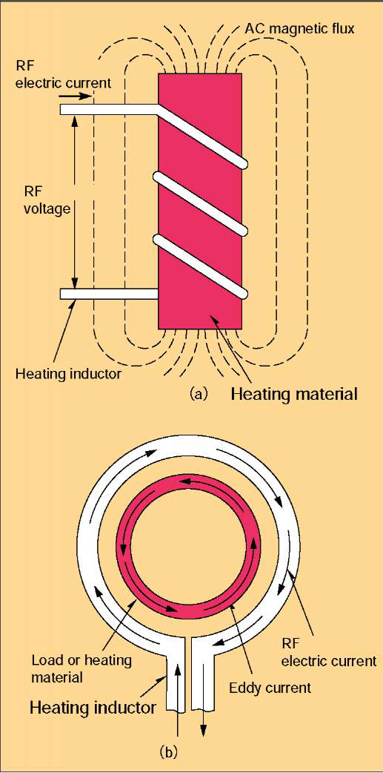

Alternating current flowing through a coil generates a magnetic field. The strength of the field varies in relation to the strength of the current passing through the coil.

The field is concentrated in the area enclosed by the coil; while its magnitude depends on the strength of the current and the number of turns in the coil. (Fig. 1)

Eddy currents are induced in any electrically conductive object—a metal bar, for example—placed inside the coil. The phenomenon of resistance generates heat in the area where the eddy currents are flowing. Increasing

the strength of the magnetic field increases the heating effect. However, the total heating effect is also influenced by the magnetic properties of the object and the distance between it and the coil. (Fig. 2)

The eddy currents create their own magnetic field that opposes the original field produced by the coil. This opposition prevents the original field from immediately penetrating to the center of the object enclosed by the coil. The eddy currents are most active close to the surface of the object being heated, but weaken considerably in strength towards the center. (Fig. 3)

The distance from the surface of the heated object to the depth where current density drops to 37% is the penetration depth. This depth increases in correlation to decreases in frequency. It is therefore essential to select the correct frequency in order to achieve the desired penetration depth.

**The principle of induction heating** by RF electric current is shown in Fig.-1, there an electric conductor such as iron or steel placed in the inductor is heated rapidly by induced eddy current caused by electromagnetic induction, and hysteretic heat loss, which is generated by vibration and friction of each molecule in magnetic material under AC magnetic flux.

As RF frequency, which is higher than that of commercial electric power, is used for induction heating, induced current flows only in the limited area near surface of heated material because of skin effect and proximity effect, and heat loss occurs only there by eddy current and hysteretic loss. The skin effect is the phenomenon, which RF electric current flows only in the limited area near surface of conductive material, and proximity effect is the phenomenon, which the primary current in the inductor and the secondary current in the conductive material pull each other because the direction of current is opposite each other, and flows in the limited area near surface where distance is nearest each other.

Fig.-2 shows the relation between frequency and depth of RF electric current flow for steel material heated by induction at 1,000 degree. The depth depends upon the frequency and as the frequency is higher, the depth becomes smaller as shown in the curves in Fig.-2.

The penetration depth is defined as the point where RF electric current decreases to about 37% (1/e =1/2.718=0.368; e is the base of natural logarithm) compared with the current at the surface and normally expressed as S . In Fig.-2, the penetration depth is shown as the points, which are the cross points of line A with the current penetration curves. The penetration depth S is calculated as follows.

S =5.03 x/^rf (cm)

S = penetration depth (cm) j = specific permeability

(magnetic material: j>1, non-magnetic material: j = 1 ) f = frequency (Hz) p = specific resistance (jQ' cm)

This formula shows that as the frequency is higher, S will be smaller and the heating will be concentrated at the surface in case the materials are same. However in actual heating, the heated depth tends to become bigger because of heat conduction in the heated material. (Refer to Setting of Hardening Condition item (3) Choice of frequency)

Induction coil

**The induction coil, also known as an ‘inductor’, is essential to the induction heating process. Many factors contribute to a coil’s effectiveness: the care taken to make it, the quality of the materials used, its shape, its maintenance, its correct matching with the power source, etc. That’s why it’s so important to insist on professionally made and maintained coils—preferably from the same people who made your induction system.**

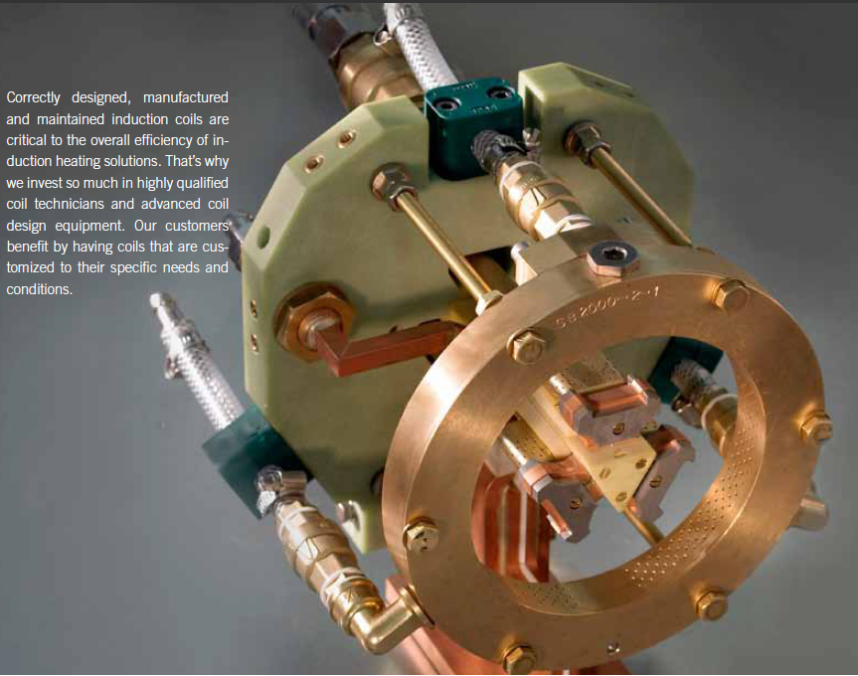

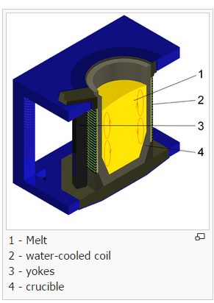

Induction furnace

An **induction furnace** is an electrical [furnace](https://en.wikipedia.org/wiki/Furnace) in which the heat is applied by [induction heating](https://en.wikipedia.org/wiki/Induction_heating) of [metal](https://en.wikipedia.org/wiki/Metal).[[1]](https://en.wikipedia.org/?title=Induction_furnace#cite_note-Laughton-1)[[2]](https://en.wikipedia.org/?title=Induction_furnace#cite_note-Campbell-2)[[3]](https://en.wikipedia.org/?title=Induction_furnace#cite_note-Bauccio-3) Induction furnace capacities range from less than one kilogram to one hundred tonnes capacity and are used to melt [iron](https://en.wikipedia.org/wiki/Iron) and [steel](https://en.wikipedia.org/wiki/Steel), [copper](https://en.wikipedia.org/wiki/Copper), [aluminium](https://en.wikipedia.org/wiki/Aluminium" \o "Aluminium) and [precious metals](https://en.wikipedia.org/wiki/Precious_metals).

The advantage of the induction furnace is a clean, energy-efficient and well-controllable melting process compared to most other means of metal melting. Most modern[foundries](https://en.wikipedia.org/wiki/Foundries) use this type of furnace, and now also more iron foundries are replacing [cupolas](https://en.wikipedia.org/wiki/Cupola_furnace) with induction furnaces to melt [cast iron](https://en.wikipedia.org/wiki/Cast_iron), as the former emit lots of [dust](https://en.wikipedia.org/wiki/Dust) and other [pollutants](https://en.wikipedia.org/wiki/Pollutant).[[4]](https://en.wikipedia.org/?title=Induction_furnace#cite_note-4)

Since no arc or combustion is used, the temperature of the material is no higher than required to melt it; this can prevent loss of valuable alloying elements.[[5]](https://en.wikipedia.org/?title=Induction_furnace#cite_note-5) The one major drawback to induction furnace usage in a foundry is the lack of refining capacity; charge materials must be clean of oxidation products and of a known composition and some alloying elements may be lost due to oxidation (and must be re-added to the melt).

## Types[[edit](https://en.wikipedia.org/w/index.php?title=Induction_furnace&action=edit&section=1" \o "Edit section: Types)]

In the coreless type,[[6]](https://en.wikipedia.org/?title=Induction_furnace" \l "cite_note-6) metal is placed in a [crucible](https://en.wikipedia.org/wiki/Crucible) surrounded by a water-cooled [alternating current](https://en.wikipedia.org/wiki/Alternating_current) [solenoid](https://en.wikipedia.org/wiki/Solenoid) coil. A channel-type induction furnace has a loop of molten metal, which forms a single-turn secondary winding through an iron core.[[7]](https://en.wikipedia.org/?title=Induction_furnace#cite_note-7)[[8]](https://en.wikipedia.org/?title=Induction_furnace#cite_note-8)

Operation

An induction furnace consists of a nonconductive crucible holding the charge of metal to be melted, surrounded by a coil of copper wire. A powerful [alternating current](https://en.wikipedia.org/wiki/Alternating_current) flows through the wire. The coil creates a rapidly reversing [magnetic field](https://en.wikipedia.org/wiki/Magnetic_field) that penetrates the metal. The magnetic field induces [eddy currents](https://en.wikipedia.org/wiki/Eddy_current), circular electric currents, inside the metal, by [electromagnetic induction](https://en.wikipedia.org/wiki/Electromagnetic_induction).[[9]](https://en.wikipedia.org/?title=Induction_furnace#cite_note-Bhattacharya-9) The eddy currents, flowing through the [electrical resistance](https://en.wikipedia.org/wiki/Electrical_resistance) of the bulk metal, heat it by [Joule heating](https://en.wikipedia.org/wiki/Joule_heating). In[ferromagnetic](https://en.wikipedia.org/wiki/Ferromagnetic) materials like [iron](https://en.wikipedia.org/wiki/Iron), the material may also be heated by [magnetic hysteresis](https://en.wikipedia.org/wiki/Magnetic_hysteresis), the reversal of the molecular[magnetic dipoles](https://en.wikipedia.org/wiki/Magnetic_dipole) in the metal. Once melted, the eddy currents cause vigorous stirring of the melt, assuring good mixing. An advantage of induction heating is that the heat is generated within the furnace's charge itself rather than applied by a burning fuel or other external heat source, which can be important in applications where contamination is an issue.

Operating frequencies range from [utility frequency](https://en.wikipedia.org/wiki/Utility_frequency) (50 or 60 [Hz](https://en.wikipedia.org/wiki/Hertz)) to 400 kHz or higher, usually depending on the material being melted, the capacity (volume) of the furnace and the melting speed required. Generally, the smaller the volume of the melts, the higher the frequency of the furnace used; this is due to the [skin depth](https://en.wikipedia.org/wiki/Skin_depth) which is a measure of the distance an alternating current can penetrate beneath the surface of a [conductor](https://en.wikipedia.org/wiki/Electrical_conductor). For the same conductivity, the higher frequencies have a shallow skin depth—that is less penetration into the melt. Lower frequencies can generate stirring or turbulence in the metal.

A preheated, one-tonne furnace melting iron can melt cold charge to tapping readiness within an hour. Power supplies range from 10 kW to 42 MW, with melt sizes of 20 kg to 65 tonnes of metal respectively.[[10]](https://en.wikipedia.org/?title=Induction_furnace#cite_note-10)

An operating induction furnace usually emits a hum or whine (due to fluctuating magnetic forces and [magnetostriction](https://en.wikipedia.org/wiki/Magnetostriction" \o "Magnetostriction)), the pitch of which can be used by operators to identify whether the furnace is operating correctly or at what power level.

